https://github.com/dotlogon/ETL-demo **The Ultimate PDI Workflow Build Guide (Step-by-Step, UI Focused)**

This transformation is built around three parallel streams: POS Sales (GBP), Online Sales (EUR), and Market Rates (Lookup), which are then combined and processed.  
  
**Sample Workflow developed on Pentaho**  


a. Database connections (sqlite)

|  |
| --- |
| <https://sqlite.org/download.html> [sqlite-tools-win-x64-3500400.zip](https://sqlite.org/2025/sqlite-tools-win-x64-3500400.zip)  PS D:\sqlite> .\sqlite3.exe D:\sqlite\pos_data.sqlite  -- Example DDL for your POS data  sqlite> CREATE TABLE IF NOT EXISTS pos_sales (  Transaction_ID TEXT PRIMARY KEY,  StoreID INTEGER,  Date_of_Sale TEXT, -- SQLite often uses TEXT for dates  Item_Sold TEXT,  Amount_Paid REAL,  Item_Cost_GBP REAL  );  sqlite> .tables  sqlite> INSERT INTO pos_sales (Transaction_ID, StoreID, Date_of_Sale, Item_Sold, Amount_Paid, Item_Cost_GBP)  VALUES ('POS2001', 12, '2025-10-25', 'Item X', 75.00, 40.00);  sqlite> INSERT INTO pos_sales (Transaction_ID, StoreID, Date_of_Sale, Item_Sold, Amount_Paid, Item_Cost_GBP)  VALUES ('POS2002', 15, '2025-10-26', 'Item Y', 200.00, 110.00);  sqlite> INSERT INTO pos_sales (Transaction_ID, StoreID, Date_of_Sale, Item_Sold, Amount_Paid, Item_Cost_GBP)  VALUES ('POS2003', 12, '2025-10-27', 'Item X', 75.00, 40.00);  sqlite> SELECT * FROM pos_sales LIMIT 5;  sqlite> .quit |

Install Pentaho  
<https://pentaho.com/pentaho-developer-edition/#communityProducts>  
Enter any details and then you get download list, select below one and download.

pdi-ce-10.2.0.0-222.zip  
  
D:\pentaho > Spoon.bat

In Pentaho UI , follow this.  
  
File 🡪 New 🡪 Transformations (Save the transformation immediately )  
Design 🡪 Input 🡪 Table input 🡪 New

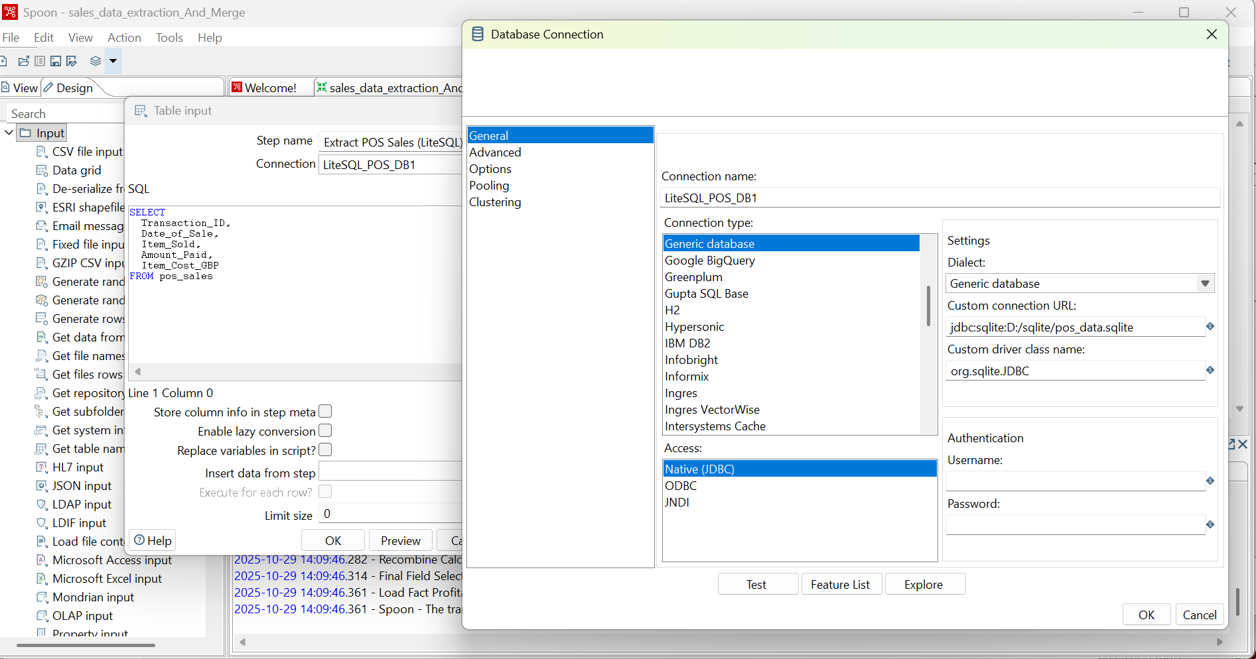

Connection type (sqlite)  
Generic database

Custom connection URL:  
jdbc:sqlite:D:/sqlite/pos_data.sqlite

Custum driver class name  
org.sqlite.JDBCClick test to test connection

**1. Phase 1: Extraction & Unification**

**A. POS Sales Stream (SQLite/GBP)**

1. **Extract POS Sales (LiteSQL) (Table Input)**
   * **Double-click** the step.
   * Select your **SQLite database connection**.
   * Enter your SELECT query (e.g., SELECT Sale_ID, Sale_Date, Product_Item, Amount, Cost FROM pos_sales;).
2. **Convert POS Date to Date Type (Select Values)**
   * **Meta-data Tab:** Click **Get fields to change**.
   * Find the **Sale_Date** field.
   * Change the **Type** column value to **Date**. *This is critical for joining.*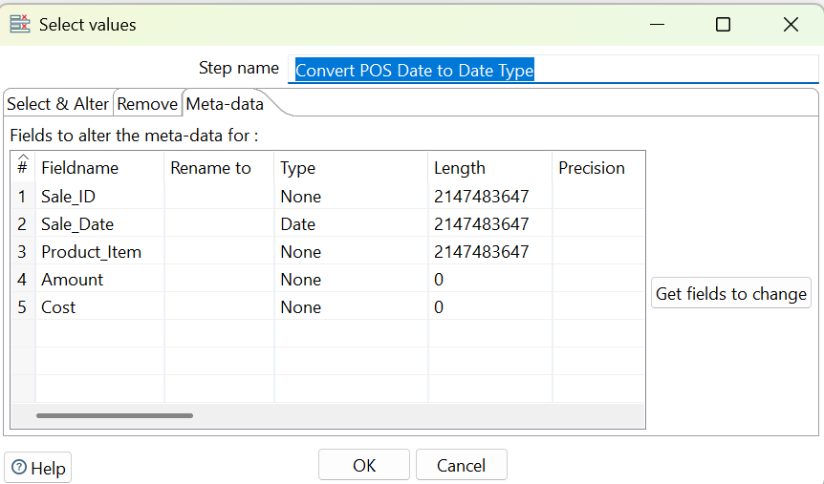
3. **Standardize POS Fields (Select Values)**
   * **Select & Alter Tab:** Click **Get fields**.
   * Ensure the fields are present in the order they will be merged (e.g., Sale_ID, Sale_Date, Product_Item, Amount, Cost).  
     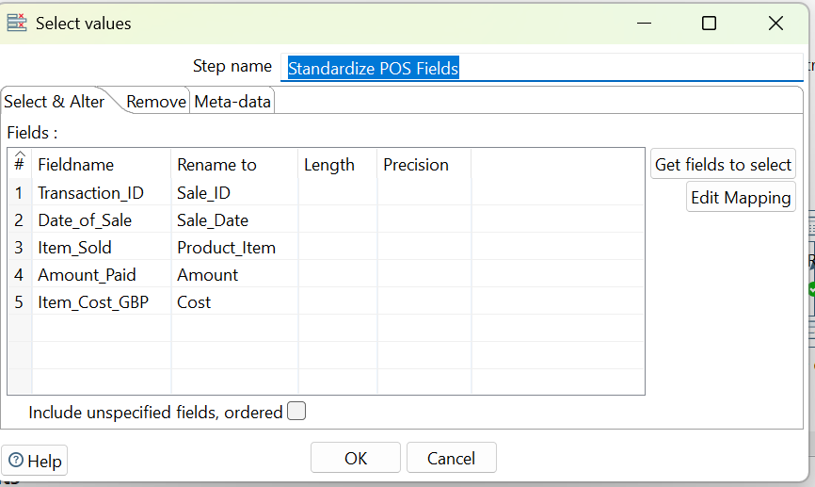
4. **Add GBP Currency (Add Constants)**
   * **Add Field:**
     + **Name:** Source_Currency
     + **Type:** String
     + **Value:** GBP  
       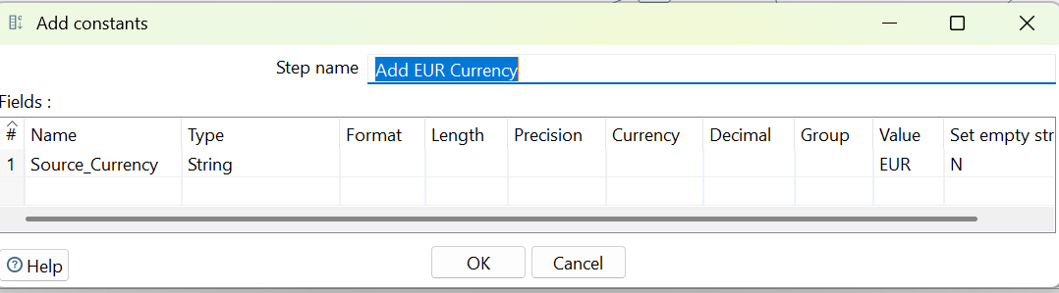

**B. Online Sales Stream (MySQL/EUR)**Important : Copy mysql-connector-j-9.5.0.jar to   
**D:\pentaho\lib\** **mysql-connector-j-9.5.0.jar**

|  |
| --- |
| **mysql details**  Database etl_source_db  user : etl_user password : abcd  mysql shell --> from windows programs (after installing mysql )  MySQL JS > \connect root@localhost <no password set>  MySQL localhost:33060+ ssl JS > \sql  DROP USER IF EXISTS 'etl_user'@'localhost'; CREATE USER 'etl_user'@'localhost' IDENTIFIED BY 'abcd'; GRANT SELECT, INSERT, UPDATE, DELETE, CREATE ON etl_source_db.* TO 'etl_user'@'localhost'; FLUSH PRIVILEGES; SELECT host, user, authentication_string FROM mysql.user WHERE user = 'etl_user';  MySQL JS > \connect root@localhost  <no password set>  MySQL localhost:33060+ ssl JS > \sql MySQL localhost:33060+ ssl SQL > show database; MySQL localhost:33060+ ssl SQL > use etl_source_db MySQL localhost:33060+ ssl SQL > show tables; CREATE USER 'etl_user'@'localhost' IDENTIFIED BY 'abcd'; GRANT SELECT, INSERT, UPDATE, DELETE, CREATE ON etl_source_db.* TO 'etl_user'@'localhost'; FLUSH PRIVILEGES;  **Populating Sample Data**  -- Insert Command 1 (Sale on 2025-10-25)  INSERT INTO online_sales (Online_Sale_ID, Customer_ID, Sale_Date, Product_Name, Sale_Amount, Product_Cost) VALUES ('ON1001', 'CUST001', '2025-10-25', 'Widget A', 150.00, 80.00);  -- Insert Command 2 (Sale on 2025-10-25)  INSERT INTO online_sales (Online_Sale_ID, Customer_ID, Sale_Date, Product_Name, Sale_Amount, Product_Cost) VALUES ('ON1002', 'CUST002', '2025-10-25', 'Gadget B', 50.00, 20.00);  -- Insert Command 3 (Sale on 2025-10-26)  INSERT INTO online_sales (Online_Sale_ID, Customer_ID, Sale_Date, Product_Name, Sale_Amount, Product_Cost) VALUES ('ON1003', 'CUST003', '2025-10-26', 'Widget A', 150.00, 80.00);  select * from online_sales;  **Create final FACT table.**  CREATE TABLE IF NOT EXISTS fact_profitability (Profit_Key INT PRIMARY KEY AUTO_INCREMENT,Sale_ID VARCHAR(20),Sale_Date DATE,Source_Currency VARCHAR(10), Product_Item VARCHAR(100),Sale_Amount_USD DECIMAL(10, 2),Profit_USD DECIMAL(10, 2),Currency_Rate_Used DECIMAL(5, 4) ); |

Design 🡪 Input 🡪 Table input 🡪 New 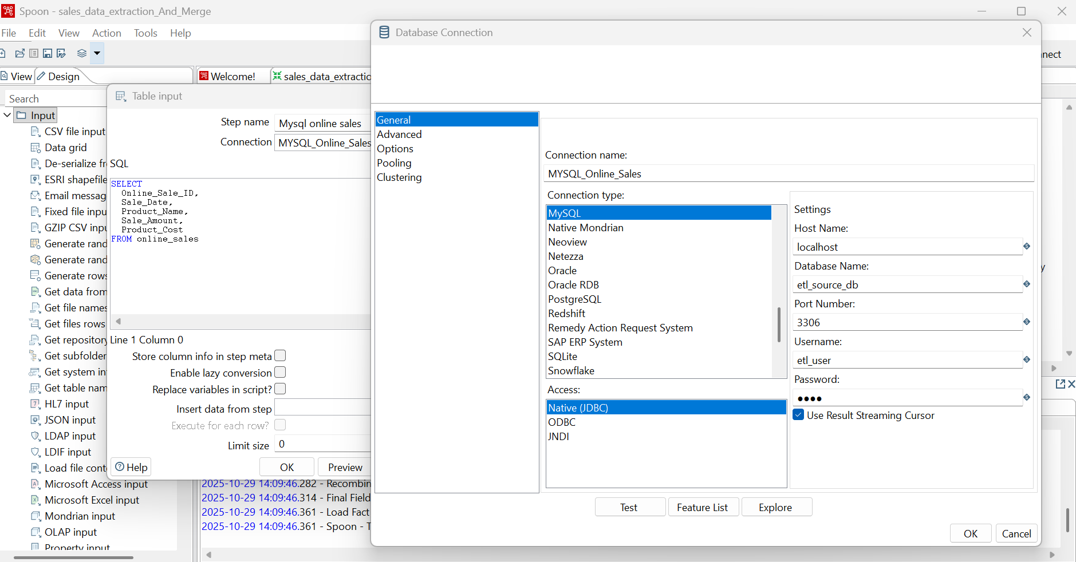

Connection type  
MySql  
  
Access:  
Nate(JDBC)

1. **Mysql online sales (Table Input)**
   * **Double-click** the step.
   * Select your **MySQL database connection**.
   * Enter your SELECT query (e.g., SELECT Sale_ID, Sale_Date, Product_Item, Amount, Cost FROM online_sales;).
2. **Standardize Online Fields (Select Values)**
   * Use the **Select & Alter Tab** to ensure the field names, types, and order exactly match the POS stream's fields (Step 3).
3. **Add EUR Currency (Add Constants)**
   * **Add Field:**
     + **Name:** Source_Currency
     + **Type:** String
     + **Value:** EUR
4. **Combine Sales Data (Append Streams)**
   * Connect the output of **Add GBP Currency** (First Stream) and **Add EUR Currency** (Second Stream) to this step.
   * No configuration is needed if the field metadata matches.

**2. Phase 2: Enrichment & Cleansing (The Fixes)**

**A. Market Rates Cleansing Path (The Lookup Stream)**

1. **Load Market Rates (CSV) (CSV File Input)**
   * **Content Tab:** Specify the file path for daily_rates.txt.
   * **Fields Tab:** Click **Get Fields**.
   * **CRITICAL FIX:** For the EUR_to_USD and GBP_to_USD fields, manually change the **Type** column value to **String**. *This prevents the step from failing on the "Error" text.*
2. **Convert Rates to String (Select Values)**
   * **Meta-data Tab:** Confirm the GBP_to_USD field's Type is **String**.
3. **Cleanse GBP Rate (Replace in string)**
   * **CRITICAL FIX:** Configure the step to replace the error text:
     + **In stream field:** GBP_to_USD
     + **Out stream field:** GBP_to_USD
     + **use RegEx:** Y
     + **Search:** ^.*Error.*$ (This matches "Error" regardless of hidden spaces or characters).
     + **Replace with:** 1.20 (A valid numeric string for the fallback rate).
4. **Convert Rates to Number (Select Values)**
   * **CRITICAL FIX:** **Meta-data Tab:**
     + Find EUR_to_USD and change **Type** to **Number**.
     + Find GBP_to_USD and change **Type** to **Number**.
   * *This completes the lookup data preparation.*

**B. Order Control and Lookup**

1. **Wait for Rates Load (Block this step until steps finish)**
   * **Draw Hop:** Draw a hop from **Combine Sales Data** to this step (This is the **Main Stream**).
   * **Configuration:** Click **Get steps**.
     + Ensure the **only** step listed is **Convert Rates to Number**. *This forces the lookup data to finish loading before the sales data proceeds.*
2. **Lookup Exchange Rate (Stream Lookup)**
   * **Draw Hops (Order is Critical!):**
     + **Hop 1 (Lookup Stream):** From **Convert Rates to Number** to **Lookup Exchange Rate**. (Draw this first).
     + **Hop 2 (Main Stream):** From **Wait for Rates Load** to **Lookup Exchange Rate**.
   * **Configuration:**
     + **Lookup step:** Select **Convert Rates to Number**.
     + **Key(s) to look up the value(s):**
       - **Field (Main Stream):** Sale_Date
       - **LookupField (Lookup Stream):** market_date
     + **Specify the fields to retrieve:** Click **Get lookup fields** and select **EUR_to_USD** and **GBP_to_USD**.

**3. Phase 3: Transformation & Load**

1. **Filter by Currency (Filter Rows)**
   * **Condition:** Source_Currency = EUR (Select the **(String)** option).
   * **True Destination:** **Calc EUR to USD**
   * **False Destination:** **Calc GBP to USD**
2. **Calc EUR to USD / Calc GBP to USD (Calculator)**
   * **New field:** Sale_Amount_USD
   * **Calculation:** A * B
   * **Field A:** Amount
   * **Field B (EUR):** EUR_to_USD
   * **Field B (GBP):** GBP_to_USD
3. **Recombine Calculated Data (Append Streams)**
   * Merge the outputs of the two Calc... steps.
4. **Final Field Selection (Select Values)**
   * **Select & Alter Tab:** **Rename:** Find **Source_Currency** and set **Rename to** as **Source_System** (if that's the name in your MySQL table).
   * **Remove Tab:** Click **Get fields to remove** and select the now-redundant fields: EUR_to_USD and GBP_to_USD.
5. **Load Fact Profitability (Table Output)**
   * **Configuration:** Select your **MySQL database connection** and the target table, fact_profitability.
   * **Database Fields Tab:** **CRITICAL FINAL FIX:** Click **Get fields**. **Manually verify** that the column names in the **Table field** column exactly match the names in the **Stream field** column (e.g., ensure Source_System in the table maps to the renamed field from Step 18).